THE WARREN COUNTY AGRICULTURAL SOCIETY
OPERATING
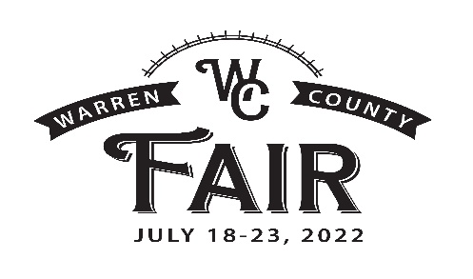
665 N. Broadway, Lebanon Ohio 45036 PHONE: 513.932.2636
2022 Food Concessions Application
THIS IS AN APPLICATION TO BE CONSIDERED AS A CONCESSIONAIRE FOR THE 2022 WARREN COUNTY FAIR. BY COMPLETING THIS APPLICATION, YOU GIVE THE WARREN COUNTY AGRICULTURAL SOCIETY PERMISSION TO CONTACT YOU AND YOUR REFERENCES.
NAME OF BUSINESS/ORGANIZATION: ___________________________________________________
NAME OF CONTACT PERSON: __________________________________________________________
ADDRESS: ___________________________________________________________________________
STREET CITY STATE ZIP

PRIMARY PHONE___________________ OTHER ________________ EMAIL: ____________________
LIST SOCIAL MEDIA SITES: _____________________________________________________________
MENU ITEMS AVAILABLE: _______________________________________________________________
______________________________________________________________________________________
REQUIREMENTS
ITEM | LINEAR FEET | 110 VOLT | 22O  VOLT | 30 AMP | 50 AMP | GENERATOROTHER | WATER
TRAILER
TENT/BOOTH
STOCK TRAILER
BUNKHOUSE
RV/ CAMPER
GOLF CART

SPACE | Electrical 110/220 | Stock Trailer | RV/Camper
$24/per linear foot | $125.00 | $80.00 | $150
FEES

Page Two

- PLEASE ENCLOSE/ATTACH A PHOTO OF YOUR BOOTH/TRAILER
- ALL CONCESSIONAIRES WILL NEED TO PROVIDE PROOF OF LIABILITY INSURANCE $1,000,000 MINIMUM. PROOF MUST BE ON FILE WITH CONTRACT.

This application does NOT constitute an agreement of any kind, nor does it represent an offer of space. We reserve the right to assign spaces from our waiting list to maintain a wide variety of different food, products, and types of businesses, etc. It is your responsibility to ensure that your application is complete and current.
NO MONEY IS DUE UNLESS A CONTRACT HAS BEEN ISSUED.

Please list three references of recent fairs/festivals that you have participated in.
- EVENT NAME________________________________ CONTACT PERSON_____________________
Phone Number: _________________________ Email _____________________________________

- EVENT NAME ________________________________ CONTACT PERSON ___________________
Phone Number: _________________________ Email: ____________________________________

- EVENT NAME ________________________________ CONTACT PERSON ___________________
Phone Number: _________________________ Email: ____________________________________

Please return this as soon as possible. Upon receiving your application we will notify you by emailing your acceptance and contract.

Please remit this application to: WCAS
PO Box 58
Lebanon, Ohio 45036
OR: officemanager@warrencountyfairohio.org

