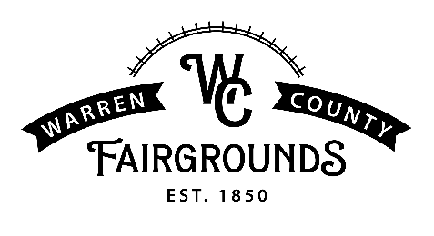
VENDOR APPLICATION
2023 WARREN COUNTY FAIR
JULY 17TH - JULY 22nd

JULY 17TH – JULY 22nd, 2023
665 N. Broadway Mailing Address: P.O. Box 58
Lebanon Ohio 45036 Phone: 513.932.263 Email officemanager@warrencountyfairohio.org

Thank you for your interest in a vendor (non-food) space at the 2023 Warren County Fair. Receipt of this application does not guarantee Vendor/Exhibitor space and is valid for the 2023 Warren County Fair only. By completing this application, you give the Warren County Agricultural Society permission to contact you and your references.
NAME OF BUSINESS/ORGANIZATION: _______________________________________________
NAME OF CONTACT PERSON: ______________________________ TITLE: ________________________
ADDRESS: _____________________________________________________________________________
STREET CITY STATE ZIP

PRIMARY PHONE: ____________________________ EMAIL:_____________________________________
LIST SOCIAL MEDIA SITES: ________________________________________________________________
LIST PRODUCTS/SERVICES YOU PLAN TO OFFER AT YOUR BOOTH. PLEASE BE SPECIFIC. WORDS SUCH AS ACCESSORIES AND RELATED PRODUCTS ARE NOT ACCEPTABLE. ____________________________________________________________________________________
_____________________________________________________________________________________________________
Please check: _____ New Vendor _____ Returning Vendor. We are interested in the following:
___ Exterior Vendor Space outside 10x10 @ $325 includes electric and one weekly pass*.
___ Exterior Vendor Space outside 20x10 @ $425 includes electric and one weekly pass*.
~You must supply your own chairs, table, fan, electrical cord, lights, tent (if outside), weights, signage. ~
___ Interior Vendor Space (Event Center) 8x6 @ $325 Includes electric and one weekly pass*.
____ Interior Vendor Space (Event Center) 16x6 @ $425 Includes electric and one weekly pass*.
~ You must supply your own chairs, tables, electrical cord, and signage. ~
* Everyone must have a Season or Membership pass ($35) to enter the grounds.
Mon - Thurs admission is $12; Fri and Sat admission is $15. Free Parking. Vendor parking will be first come first serve.
Office Use Only
Sent Application _______________
Received Application ___________
Notified Accepted _____________
Declined ___ _________________
Contract Sent _________________

Vendor Application - Due June 1^{st,} 2023. Early bird application before April 1st will receive a discount of $25.00 off space rental!
Notification of acceptance by Warren County Fair will be sent no later than June 15^{th 2023}
Completed contract and payment are to be sent upon receipt of acceptance.

